LAB 11 ANP-C7781

Solve following questions:

Questions :-

Solve below questions:

1.     CREATE HIBERNATE CRUD OPERATIONS USING entity of your choice. Get the details from respective table using SQL. Define the necessary tables/entities to represent relevant information. Perform update and delete operation.

2.     You are working on a Java application to manage information about students and their respective addresses. Implement a one-to-one association between the Student and Address entities using Hibernate.

 3.     You are working on a Java application to manage information about employees and their respective departments. Implement a one-to-many association between the Employee and Department entities using Hibernate.

Solutions :-

1.     CREATE HIBERNATE CRUD OPERATIONS USING entity of your choice. Get the details from respective table using SQL. Define the necessary tables/entities to represent relevant information. Perform update and delete operation.

Program :-

***(Student.java)***

package FirstProject;

import javax.persistence.Entity;

import javax.persistence.Id;

// Defines the class as an entity for Hibernate

@Entity

public class student {

// Specifies the primary key field

@Id

private int id;

private String name;

private String city;

public certificate getCerti() {

return certi;

}

public void setCerti(certificate certi) {

this.certi = certi;

}

private certificate certi;

// Parameterized constructor

public student(int id, String name, String city) {

super();

this.id = id;

this.name = name;

this.city = city;

}

// Default constructor

public student() {

super();

}

// Getter for id

public int getId() {

return id;

}

// Setter for id

public void setId(int id) {

this.id = id;

}

// Getter for name

public String getName() {

return name;

}

// Setter for name

public void setName(String name) {

this.name = name;

}

// Getter for city

public String getCity() {

return city;

}

// Setter for city

public void setCity(String city) {

this.city = city;

}

// Overridden toString method for string representation

@Override

public String toString() {

return this.id + " : " + this.name + " : " + this.city;

}

}

***(Certificate.java)***

package FirstProject;

import javax.persistence.Embeddable;

*@Embeddable*

public class certificate {

private String course;

private String duration;

public certificate(String course, String duration) {

super();

this.course = course;

this.duration = duration;

}

public certificate() {

super();

}

public String getCourse() {

return course;

}

public void setCourse(String course) {

this.course = course;

}

public String getDuration() {

return duration;

}

public void setDuration(String duration) {

this.duration = duration;

}

}

***(EmDemo.java)***

package FirstProject;

import org.hibernate.Session;

import org.hibernate.SessionFactory;

import org.hibernate.Transaction;

import org.hibernate.cfg.Configuration;

public class EmDemo {

public static void main(String[] args) {

// Configure Hibernate and build the session factory

Configuration cfg = new Configuration();

cfg.configure();

SessionFactory factory = cfg.buildSessionFactory();

// Create first student object

student std1 = new student();

std1.setId(100);

std1.setName("Mithila");

std1.setCity("Dombivali");

// Create certificate for first student

certificate certi1 = new certificate();

certi1.setCourse("Java");

certi1.setDuration("2 Months");

std1.setCerti(certi1);

// Create second student object

student std2 = new student();

std2.setId(101);

std2.setName("Pranay");

std2.setCity("Vileparle");

// Create certificate for second student

certificate certi2 = new certificate();

certi2.setCourse("Java Fullstack");

certi2.setDuration("4 Months");

std2.setCerti(certi2);

// Open a new session and begin a transaction

Session s = factory.openSession();

Transaction tx = s.beginTransaction();

// Save both student objects to the database

s.save(std1);

s.save(std2);

// Retrieve and print the first student

student stdMithila = (student) s.get(student.class, 100);

System.***out***.println(stdMithila);

// Retrieve and print the second student

student stdPranay = (student) s.get(student.class, 101);

System.***out***.println(stdPranay);

// Update the details of the first student

student stdToUpdate = (student) s.get(student.class, 100);

if (stdToUpdate != null) {

stdToUpdate.setName("Mithila Updated");

stdToUpdate.setCity("Dombivali Updated");

s.update(stdToUpdate);

System.***out***.println("Updated Student: " + stdToUpdate);

} else {

System.***out***.println("Student with ID 100 not found.");

}

// Delete the second student from the database

student stdToDelete = (student) s.get(student.class, 101);

if (stdToDelete != null) {

s.delete(stdToDelete);

System.***out***.println("Deleted Student: " + stdToDelete);

} else {

System.***out***.println("Student with ID 101 not found.");

}

// Commit the transaction to save changes

tx.commit();

// Close the session and factory to release resources

s.close();

factory.close();

}

}

Output :-

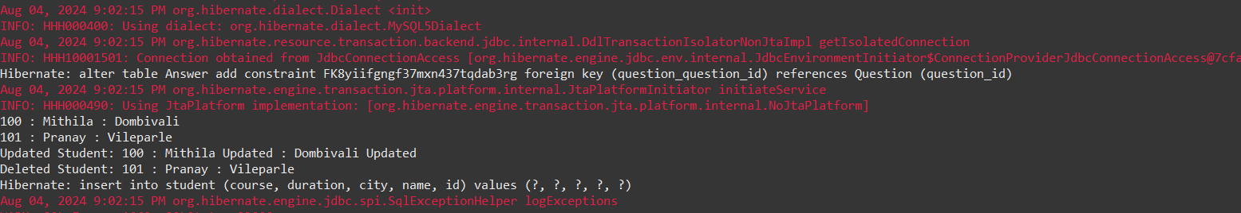

2.     You are working on a Java application to manage information about students and their respective addresses. Implement a one-to-one association between the Student and Address entities using Hibernate.

Program :-

***(Question.java)***

***package map;***

***import javax.persistence.Column;***

***import javax.persistence.Entity;***

***import javax.persistence.Id;***

***import javax.persistence.OneToOne;***

***import javax.persistence.JoinColumn;***

***@Entity***

***public class Question {***

***@Id***

***@Column(name="question_id")***

***private int questionId;***

***private String question;***

***@OneToOne***

***@JoinColumn(name = "answer_id") // Foreign key in the Question table***

***private Answer answer;***

***public Question() {***

***super();***

***}***

***public Question(int questionId, String question, Answer answer) {***

***super();***

***this.questionId = questionId;***

***this.question = question;***

***this.answer = answer;***

***}***

***public int getQuestionId() {***

***return questionId;***

***}***

***public void setQuestionId(int questionId) {***

***this.questionId = questionId;***

***}***

***public String getQuestion() {***

***return question;***

***}***

***public void setQuestion(String question) {***

***this.question = question;***

***}***

***public Answer getAnswer() {***

***return answer;***

***}***

***public void setAnswer(Answer answer) {***

***this.answer = answer;***

***}***

***}***

***(Answer.java)***

package map;

import javax.persistence.Column;

import javax.persistence.Entity;

import javax.persistence.Id;

import javax.persistence.OneToOne;

*@Entity*

public class Answer {

*@Id*

*@Column*(name="answer_id")

private int answerId;

private String answer;

*@OneToOne*(mappedBy = "answer") // This indicates the inverse side of the relationship

private Question question;

public Answer() {

super();

}

public Answer(int answerId, String answer) {

super();

this.answerId = answerId;

this.answer = answer;

}

public int getAnswerId() {

return answerId;

}

public void setAnswerId(int answerId) {

this.answerId = answerId;

}

public String getAnswer() {

return answer;

}

public void setAnswer(String answer) {

this.answer = answer;

}

public Question getQuestion() {

return question;

}

public void setQuestion(Question question) {

this.question = question;

}

}

***(MapDemo.java)***

***package map;***

***import org.hibernate.Session;***

***import org.hibernate.SessionFactory;***

***import org.hibernate.Transaction;***

***import org.hibernate.cfg.Configuration;***

***public class MapDemo {***

***public static void main(String[] args) {***

***Configuration cfg = new Configuration();***

***cfg.configure("hibernate.cfg.xml");***

***SessionFactory factory = cfg.buildSessionFactory();***

***// Creating question1 object***

***Question q1 = new Question();***

***q1.setQuestionId(1212);***

***q1.setQuestion("What is java ?");***

***// Creating answer1 object***

***Answer answer1 = new Answer();***

***answer1.setAnswerId(343);***

***answer1.setAnswer("Java is a programming language");***

***q1.setAnswer(answer1);***

***answer1.setQuestion(q1); // Set the reference back to Question***

***// Creating question2 object***

***Question q2 = new Question();***

***q2.setQuestionId(242);***

***q2.setQuestion("What is collection framework ?");***

***// Creating answer2 object***

***Answer answer2 = new Answer();***

***answer2.setAnswerId(344);***

***answer2.setAnswer("API to work with objects in java");***

***q2.setAnswer(answer2);***

***answer2.setQuestion(q2); // Set the reference back to Question***

***Session session = factory.openSession();***

***Transaction tx = session.beginTransaction();***

***session.save(answer1); // Save Answer first to maintain referential integrity***

***session.save(q1);***

***session.save(answer2); // Save Answer first to maintain referential integrity***

***session.save(q2);***

***tx.commit();***

***session.clear();***

***factory.close();***

***}***

***}***

***Output :-***

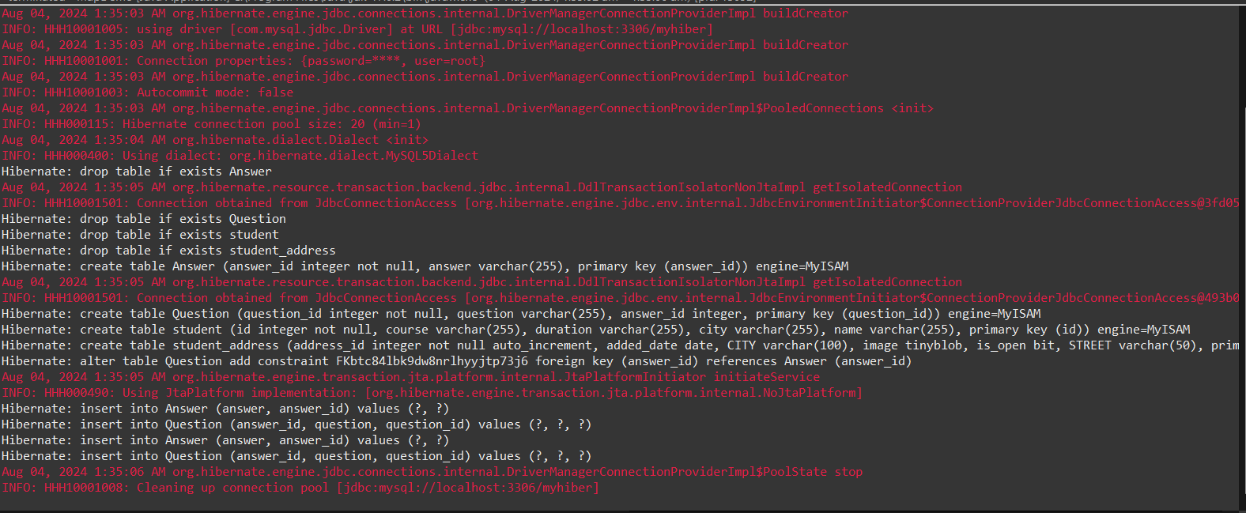

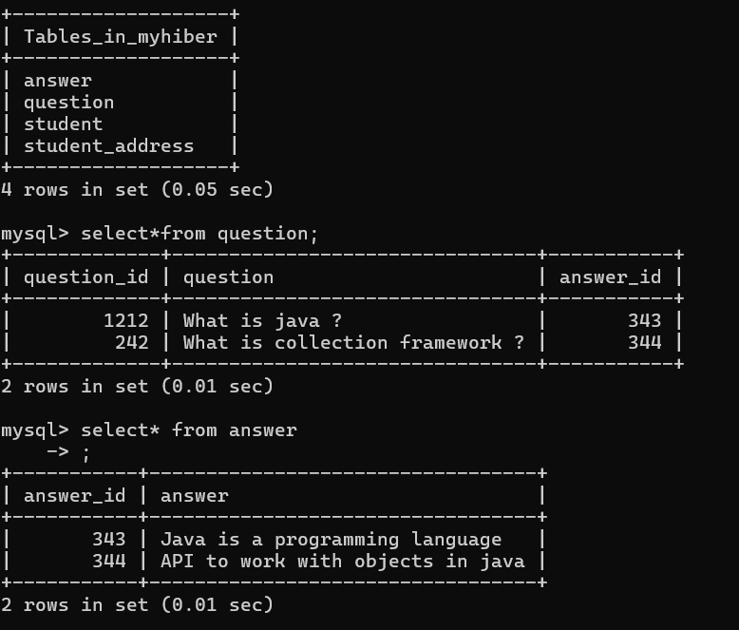

3.     You are working on a Java application to manage information about employees and their respective departments. Implement a one-to-many association between the Employee and Department entities using Hibernate.

Program :-

***(Question.java)***

package OneToOneMap;

import java.util.List;

import javax.persistence.Column;

import javax.persistence.Entity;

import javax.persistence.Id;

import javax.persistence.OneToOne;

import javax.persistence.JoinColumn;

import javax.persistence.OneToMany;

@Entity

public class Question {

@Id

@Column(name="question_id")

private int questionId;

private String question;

@OneToMany(mappedBy="question")

private List <Answer> answer;

public Question() {

super();

}

public int getQuestionId() {

return questionId;

}

public void setQuestionId(int questionId) {

this.questionId = questionId;

}

public String getQuestion() {

return question;

}

public void setQuestion(String question) {

this.question = question;

}

public Question(int questionId, String question, List<Answer> answer) {

super();

this.questionId = questionId;

this.question = question;

this.answer = answer;

}

public List<Answer> getAnswer() {

return answer;

}

public void setAnswer(List<Answer> answer) {

this.answer = answer;

}

}

***(Answer.java)***

package OneToOneMap;

import javax.persistence.Column;

import javax.persistence.Entity;

import javax.persistence.Id;

import javax.persistence.ManyToOne;

import javax.persistence.OneToOne;

@Entity

public class Answer {

@Id

@Column(name="answer_id")

private int answerId;

private String answer;

@ManyToOne

private Question question;

public Answer() {

super();

}

public Answer(int answerId, String answer) {

super();

this.answerId = answerId;

this.answer = answer;

}

public int getAnswerId() {

return answerId;

}

public void setAnswerId(int answerId) {

this.answerId = answerId;

}

public String getAnswer() {

return answer;

}

public void setAnswer(String answer) {

this.answer = answer;

}

public Question getQuestion() {

return question;

}

public void setQuestion(Question question) {

this.question = question;

}

}

***(MapDemo.java)***

package OneToOneMap;

import java.util.ArrayList;

import java.util.List;

import org.hibernate.Session;

import org.hibernate.SessionFactory;

import org.hibernate.Transaction;

import org.hibernate.cfg.Configuration;

public class MapDemo {

public static void main(String[] args) {

Configuration cfg = new Configuration();

cfg.configure("hibernate.cfg.xml");

SessionFactory factory = cfg.buildSessionFactory();

// Creating question1 object

Question q1 = new Question();

q1.setQuestionId(1212);

q1.setQuestion("What is java ?");

// Creating answer1 object

Answer answer1 = new Answer();

answer1.setAnswerId(343);

answer1.setAnswer("Java is a programming language");

answer1.setQuestion(q1); // Set the reference back to Question

Answer answer2 = new Answer();

answer2.setAnswerId(33);

answer2.setAnswer("Java is fast");

answer2.setQuestion(q1); // Set the reference back to Question

Answer answer3 = new Answer();

answer3.setAnswerId(363);

answer3.setAnswer("Java helps to build software");

answer3.setQuestion(q1); // Set the reference back to Question

List<Answer> list = new ArrayList<Answer>();

list.add(answer1);

list.add(answer2);

list.add(answer3);

q1.setAnswer(list);

Session session = factory.openSession();

Transaction tx = session.beginTransaction();

session.save(q1);

session.save(answer1);

session.save(answer2);

session.save(answer3);

// Fetching..

Question que = (Question)session.get(Question.class, 1212);

System.out.println(que.getQuestion());

for(Answer a:que.getAnswer()) {

System.out.println(a.getAnswer());

}

// Question newQ=(Question)session.get(Question.class, 1212);

// System.out.println(newQ.getQuestion());

// System.out.println(newQ.getAnswer().getAnswer());

tx.commit();

session.clear();

factory.close();

}

}

Output :-

